### Comment

In the “Comment” section you can change the names of different fields to get an overall clarity. These names can be changed for the clarity in an instrument or a logbook if the sensor has an explicit name. Sometimes you have to use an auxiliary field when the name for that sensor is not available.

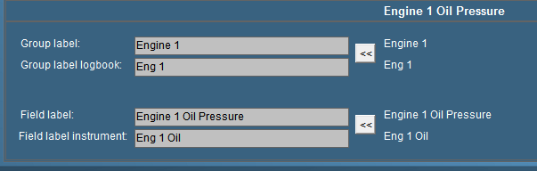

Figure 11‑18: Comment

#### Group label

Via “Group label” you can assigns a field to a specific “Alarm” group. The name is written in full so there will be no misunderstanding. It is especially handy if you have different sensors, which are arranged in different groups. Once grouped, you change them in “Group label”. For more detailed information concerning alarm groups please refer to chapter “Alarm stations”.

#### Group label logbook

is the label that is shown in the logbook (see chapter logbook). To save space you type an abbreviation of the group label. This is helpful to check in the logbook. All the alarms in the Logbook will have a group available so it is distinct where to place the alarm.

#### Field label

The field label is the exact indication of the sensor. For every sensor in FT NavVision® you need a unique ID. That ID is the field label. Whether it is already preprogrammed or you rename an auxiliary field, that field label represents from then on the sensor. Knowing this, NavVision can connect this sensor to an instrument, calculate with it etc. mostly you will see the representation of this field label in the Wago (see Wago), but it is possible you find it in other, programming or calibration files.

#### Field label instrument

The name of the sensor showed in the instrument is set in the field label instrument. While there isn’t always that much space in an instrument, we use an abbreviation of the “Field label”. If you have to make up a name yourself be sure to choose a name that is representing the sensor and is clear, even in the abbreviation.

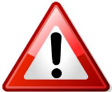*: To switch back to the old settings, just click on the arrow-button on the right side* 